SQL Built-in Functions

🌟 Definition
# Source: AI Source: Provided by: [Data Path: Persons Table -> ID Column: 1, Name_En Column: Motasem Essam] -> From: [ChatGPT] on [6/11/2026]
SQL Built-in Functions are predefined functions provided by the database management system (DBMS) to perform common operations on data.
Instead of writing complex calculations or text manipulation manually, you can use built-in functions to process data quickly and efficiently.
A function accepts one or more values (arguments), performs an operation, and returns a result.

🎯 Purpose
# Source: AI Source: Provided by: [Data Path: Persons Table -> ID Column: 1, Name_En Column: Motasem Essam] -> From: [ChatGPT] on [6/11/2026]
SQL built-in functions are used to:
- Perform mathematical calculations
- Manipulate text
- Work with dates and times
- Handle NULL values
- Convert data types
- Calculate summary statistics
- Format data for reports

📝 Syntax
# Source: AI Source: Provided by: [Data Path: Persons Table -> ID Column: 1, Name_En Column: Motasem Essam] -> From: [ChatGPT] on [6/11/2026]
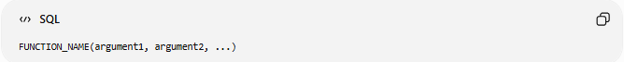
FUNCTION_NAME(argument1, argument2, ...)
Example

SELECT UPPER('sql');
Result
SQL

🔢 Categories of SQL Built-in Functions
# Source: AI Source: Provided by: [Data Path: Persons Table -> ID Column: 1, Name_En Column: Motasem Essam] -> From: [ChatGPT] on [6/11/2026]
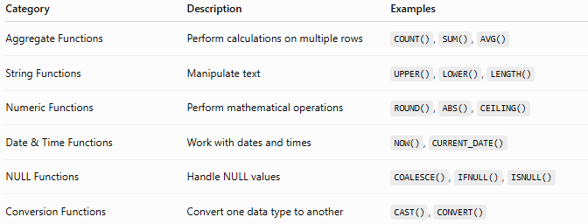
Category | Description | Examples
Aggregate Functions | Perform calculations on multiple rows | COUNT(), SUM(), AVG()
String Functions | Manipulate text | UPPER(), LOWER(), LENGTH()
Numeric Functions | Perform mathematical operations | ROUND(), ABS(), CEILING()
Date & Time Functions | Work with dates and times | NOW(), CURRENT_DATE()
NULL Functions | Handle NULL values | COALESCE(), IFNULL(), ISNULL()
Conversion Functions | Convert one data type to another | CAST(), CONVERT()

1️⃣ Aggregate Functions
# Source: AI Source: Provided by: [Data Path: Persons Table -> ID Column: 1, Name_En Column: Motasem Essam] -> From: [ChatGPT] on [6/11/2026]
Perform calculations on a group of rows and return a single value.
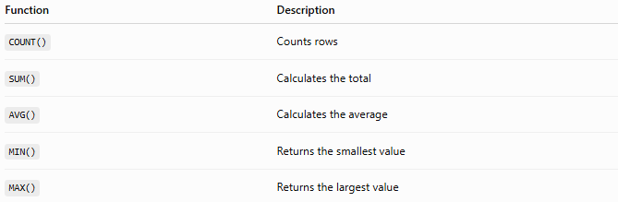
Function | Description
COUNT() | Counts rows
SUM() | Calculates the total
AVG() | Calculates the average
MIN() | Returns the smallest value
MAX() | Returns the largest value
Example
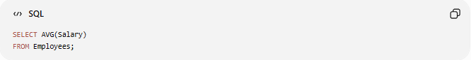
SELECT AVG(Salary)
FROM Employees;

2️⃣ String Functions
# Source: AI Source: Provided by: [Data Path: Persons Table -> ID Column: 1, Name_En Column: Motasem Essam] -> From: [ChatGPT] on [6/11/2026]
Manipulate text values.
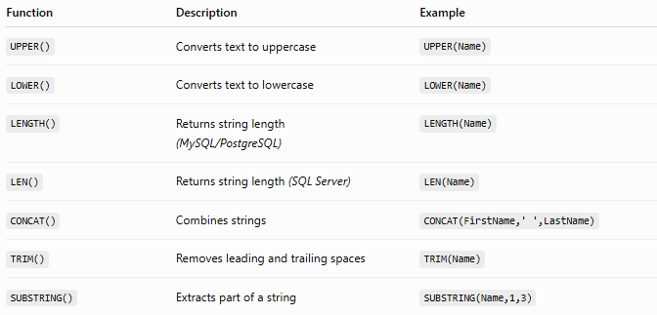
Function | Description | Example
UPPER() | Converts text to uppercase | UPPER(Name)
LOWER() | Converts text to lowercase | LOWER(Name)
LENGTH() | Returns string length (MySQL/PostgreSQL) | LENGTH(Name)
LEN() | Returns string length (SQL Server) | LEN(Name)
CONCAT() | Combines strings | CONCAT(FirstName,' ',LastName)
TRIM() | Removes leading and trailing spaces | TRIM(Name)
SUBSTRING() | Extracts part of a string | SUBSTRING(Name,1,3)
Example
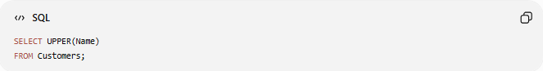
SELECT UPPER(Name)
FROM Customers;

3️⃣ Numeric Functions
# Source: AI Source: Provided by: [Data Path: Persons Table -> ID Column: 1, Name_En Column: Motasem Essam] -> From: [ChatGPT] on [6/11/2026]
Perform mathematical calculations.
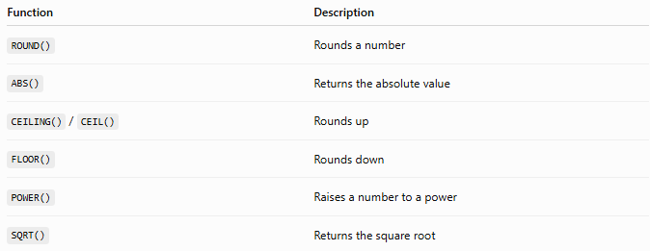
Function | Description
ROUND() | Rounds a number
ABS() | Returns the absolute value
CEILING() / CEIL() | Rounds up
FLOOR() | Rounds down
POWER() | Raises a number to a power
SQRT() | Returns the square root
Example

SELECT ROUND(123.456, 2);
Result
123.46

4️⃣ Date & Time Functions
# Source: AI Source: Provided by: [Data Path: Persons Table -> ID Column: 1, Name_En Column: Motasem Essam] -> From: [ChatGPT] on [6/11/2026]
Work with dates and times.
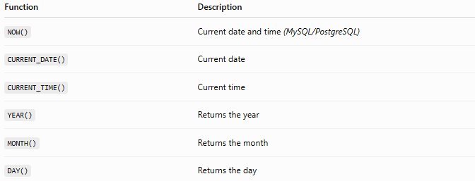
Function | Description
NOW() | Current date and time (MySQL/PostgreSQL)
CURRENT_DATE() | Current date
CURRENT_TIME() | Current time
YEAR() | Returns the year
MONTH() | Returns the month
DAY() | Returns the day
Example

SELECT CURRENT_DATE();

5️⃣ NULL Functions
# Source: AI Source: Provided by: [Data Path: Persons Table -> ID Column: 1, Name_En Column: Motasem Essam] -> From: [ChatGPT] on [6/11/2026]
Handle NULL values.
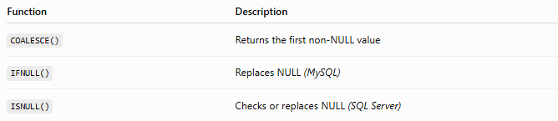
Function | Description
COALESCE() | Returns the first non-NULL value
IFNULL() | Replaces NULL (MySQL)
ISNULL() | Checks or replaces NULL (SQL Server)
Example
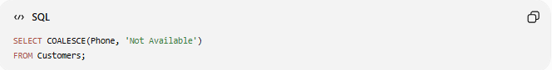
SELECT COALESCE(Phone, 'Not Available')
FROM Customers;

6️⃣ Conversion Functions
# Source: AI Source: Provided by: [Data Path: Persons Table -> ID Column: 1, Name_En Column: Motasem Essam] -> From: [ChatGPT] on [6/11/2026]
Convert one data type into another.
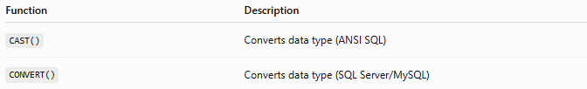
Function | Description
CAST() | Converts data type (ANSI SQL)
CONVERT() | Converts data type (SQL Server/MySQL)
Example
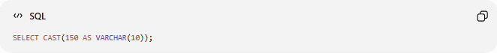
SELECT CAST(150 AS VARCHAR(10));

🛠️ Complete Test Example

Create Table
# Source: AI Source: Provided by: [Data Path: Persons Table -> ID Column: 1, Name_En Column: Motasem Essam] -> From: [ChatGPT] on [6/11/2026]
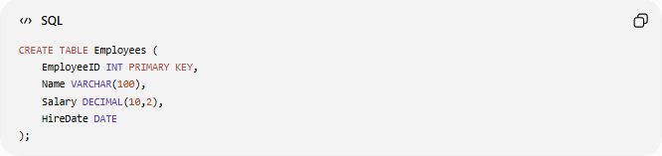
CREATE TABLE Employees (
EmployeeID INT PRIMARY KEY,
Name VARCHAR(100),
Salary DECIMAL(10,2),
HireDate DATE
);

Insert Data
# Source: AI Source: Provided by: [Data Path: Persons Table -> ID Column: 1, Name_En Column: Motasem Essam] -> From: [ChatGPT] on [6/11/2026]
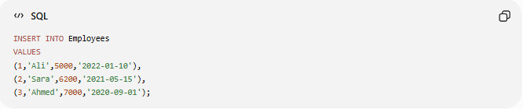
INSERT INTO Employees
VALUES
(1,'Ali',5000,'2022-01-10'),
(2,'Sara',6200,'2021-05-15'),
(3,'Ahmed',7000,'2020-09-01');

Aggregate Function
# Source: AI Source: Provided by: [Data Path: Persons Table -> ID Column: 1, Name_En Column: Motasem Essam] -> From: [ChatGPT] on [6/11/2026]
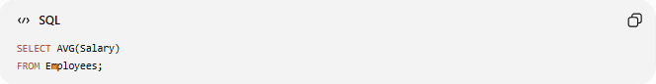
SELECT AVG(Salary)
FROM Employees;

String Function
# Source: AI Source: Provided by: [Data Path: Persons Table -> ID Column: 1, Name_En Column: Motasem Essam] -> From: [ChatGPT] on [6/11/2026]
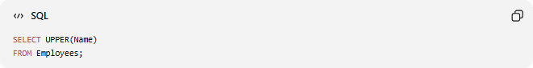
SELECT UPPER(Name)
FROM Employees;

Numeric Function
# Source: AI Source: Provided by: [Data Path: Persons Table -> ID Column: 1, Name_En Column: Motasem Essam] -> From: [ChatGPT] on [6/11/2026]

SELECT ROUND(123.456,2);

Date Function
# Source: AI Source: Provided by: [Data Path: Persons Table -> ID Column: 1, Name_En Column: Motasem Essam] -> From: [ChatGPT] on [6/11/2026]

SELECT CURRENT_DATE();

NULL Function
# Source: AI Source: Provided by: [Data Path: Persons Table -> ID Column: 1, Name_En Column: Motasem Essam] -> From: [ChatGPT] on [6/11/2026]

SELECT COALESCE(NULL,'Unknown');

Conversion Function
# Source: AI Source: Provided by: [Data Path: Persons Table -> ID Column: 1, Name_En Column: Motasem Essam] -> From: [ChatGPT] on [6/11/2026]
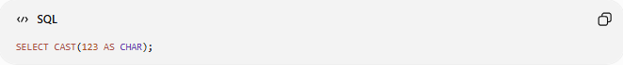
SELECT CAST(123 AS CHAR);

Real Example

prepared commands

Create Table
# Source: ScreenShot Source: Provided by: [Persons Table -> ID Column: 1, Name_En Column: Motasem Essam] -> Tool: [Automation Table -> ID Column: 16, Name_En Column: Screen Capture] -> From [Operating System: Wampserver64 -> phpmyadmin] on [6/11/2026]
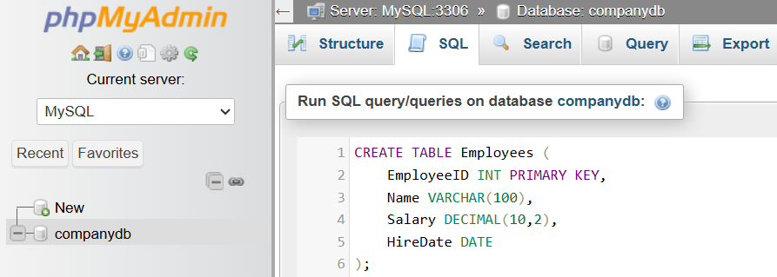
CREATE TABLE Employees (
EmployeeID INT PRIMARY KEY,
Name VARCHAR(100),
Salary DECIMAL(10,2),
HireDate DATE
);
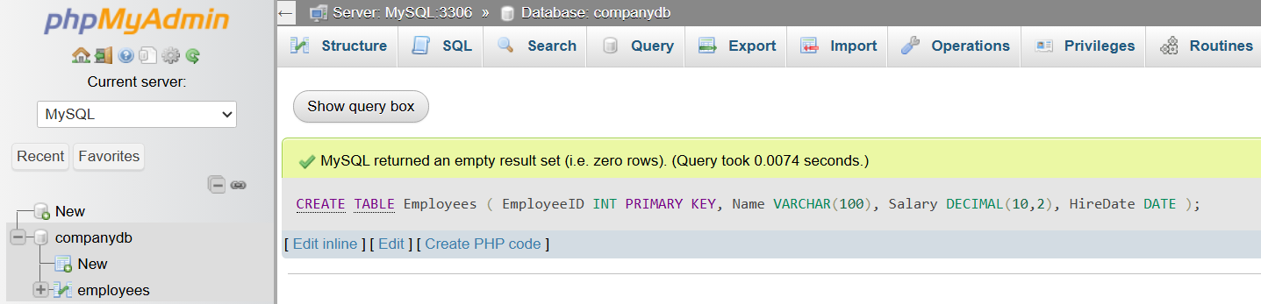

Insert Data
# Source: ScreenShot Source: Provided by: [Persons Table -> ID Column: 1, Name_En Column: Motasem Essam] -> Tool: [Automation Table -> ID Column: 16, Name_En Column: Screen Capture] -> From [Operating System: Wampserver64 -> phpmyadmin] on [6/11/2026]
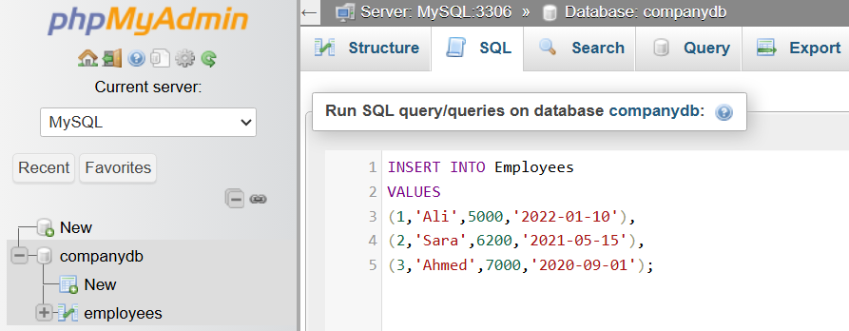
INSERT INTO Employees
VALUES
(1,'Ali',5000,'2022-01-10'),
(2,'Sara',6200,'2021-05-15'),
(3,'Ahmed',7000,'2020-09-01');
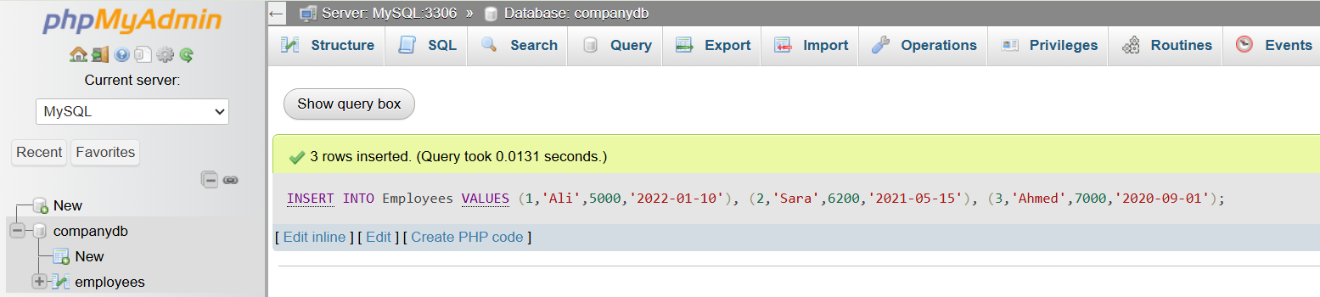

basic command

Aggregate Function
# Source: ScreenShot Source: Provided by: [Persons Table -> ID Column: 1, Name_En Column: Motasem Essam] -> Tool: [Automation Table -> ID Column: 16, Name_En Column: Screen Capture] -> From [Operating System: Wampserver64 -> phpmyadmin] on [6/11/2026]
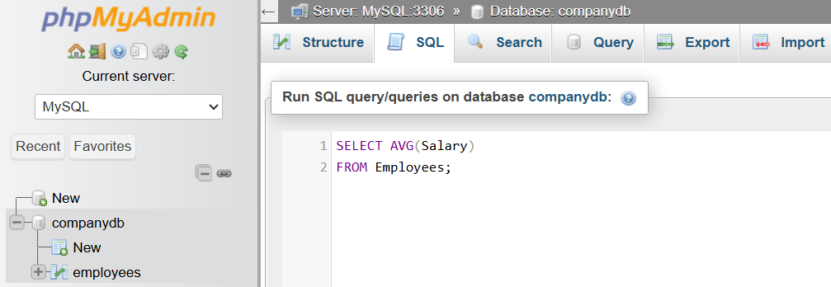
SELECT AVG(Salary)
FROM Employees;
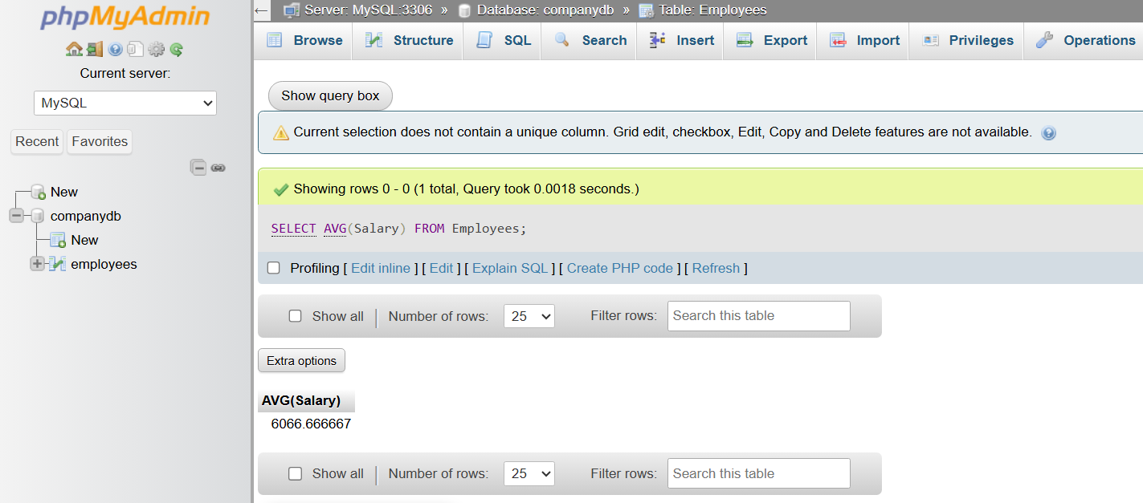

String Function
# Source: ScreenShot Source: Provided by: [Persons Table -> ID Column: 1, Name_En Column: Motasem Essam] -> Tool: [Automation Table -> ID Column: 16, Name_En Column: Screen Capture] -> From [Operating System: Wampserver64 -> phpmyadmin] on [6/11/2026]
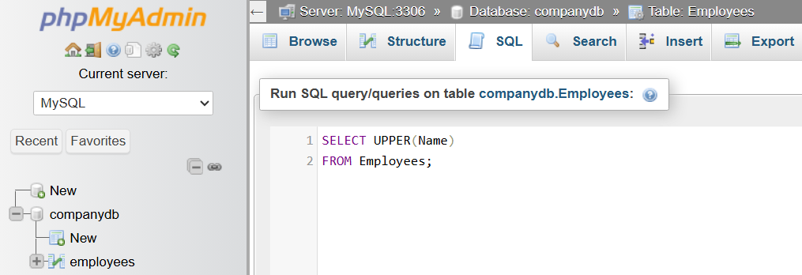
SELECT UPPER(Name)
FROM Employees;
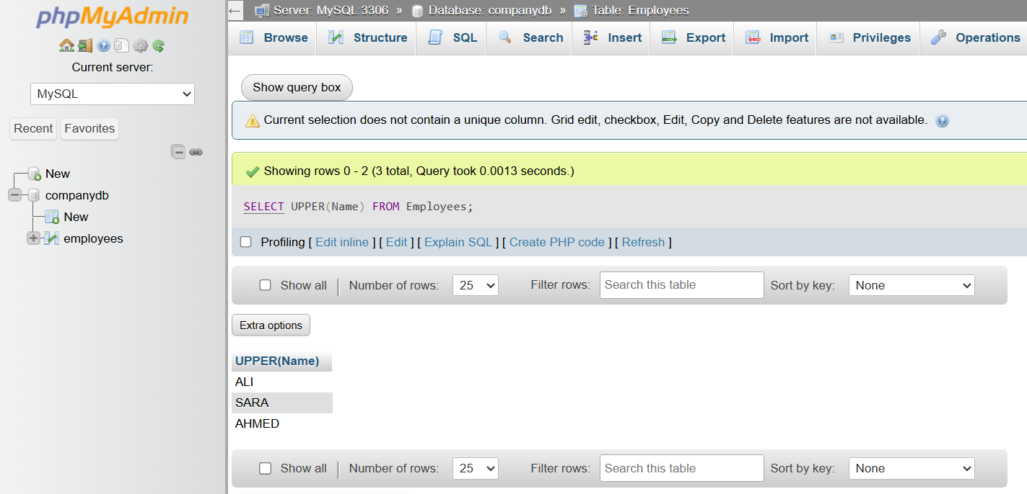

Numeric Function
# Source: ScreenShot Source: Provided by: [Persons Table -> ID Column: 1, Name_En Column: Motasem Essam] -> Tool: [Automation Table -> ID Column: 16, Name_En Column: Screen Capture] -> From [Operating System: Wampserver64 -> phpmyadmin] on [6/11/2026]
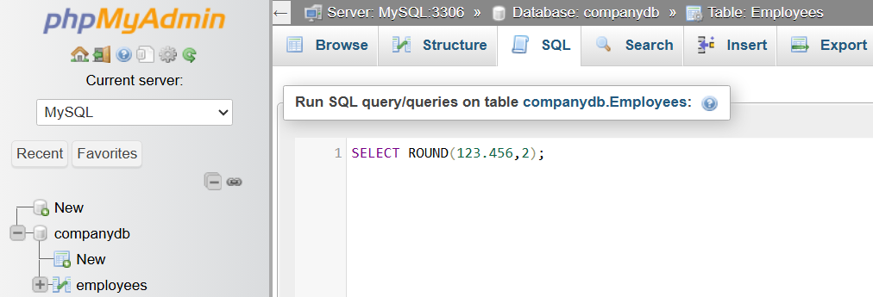
SELECT ROUND(123.456,2);
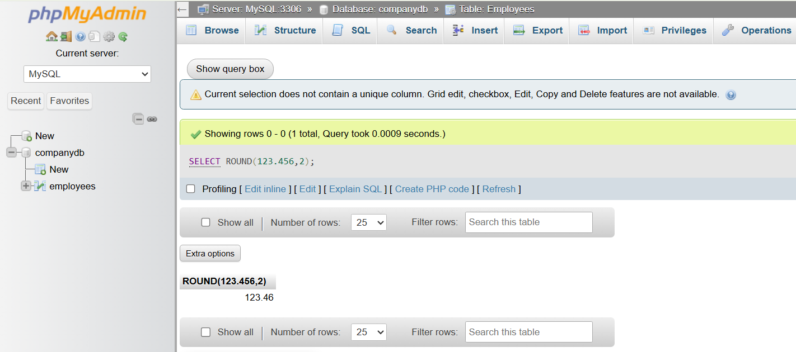

Date Function
# Source: ScreenShot Source: Provided by: [Persons Table -> ID Column: 1, Name_En Column: Motasem Essam] -> Tool: [Automation Table -> ID Column: 16, Name_En Column: Screen Capture] -> From [Operating System: Wampserver64 -> phpmyadmin] on [6/11/2026]
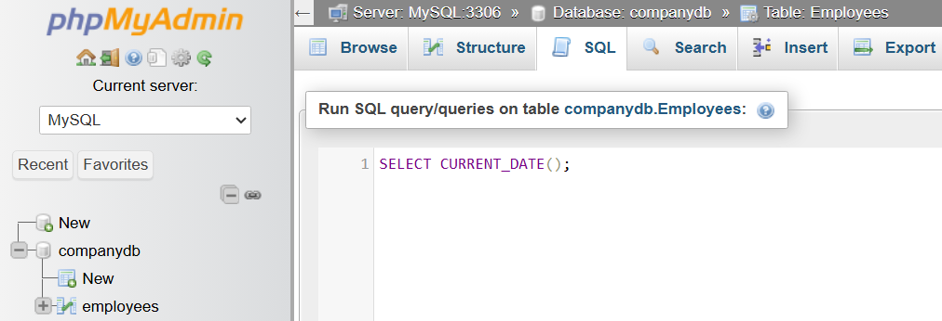
SELECT CURRENT_DATE();
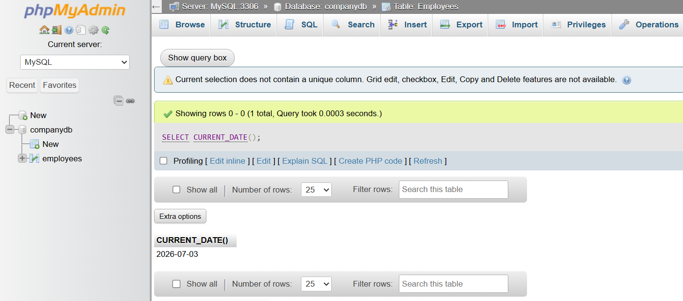

NULL Function
# Source: ScreenShot Source: Provided by: [Persons Table -> ID Column: 1, Name_En Column: Motasem Essam] -> Tool: [Automation Table -> ID Column: 16, Name_En Column: Screen Capture] -> From [Operating System: Wampserver64 -> phpmyadmin] on [6/11/2026]
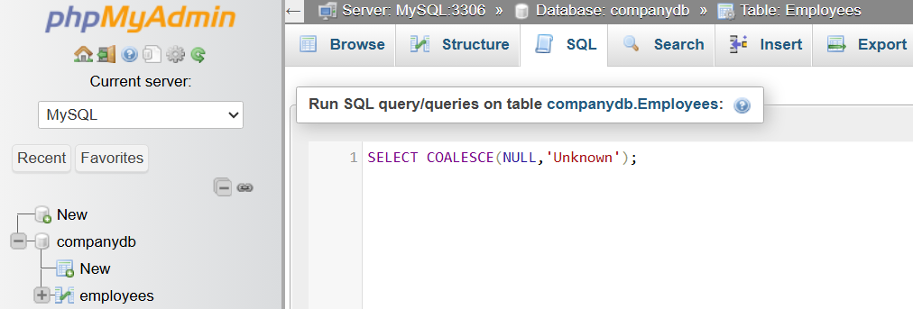
SELECT COALESCE(NULL,'Unknown');
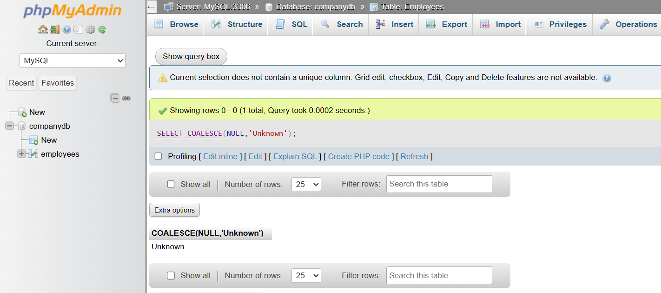

Conversion Function
# Source: ScreenShot Source: Provided by: [Persons Table -> ID Column: 1, Name_En Column: Motasem Essam] -> Tool: [Automation Table -> ID Column: 16, Name_En Column: Screen Capture] -> From [Operating System: Wampserver64 -> phpmyadmin] on [6/11/2026]
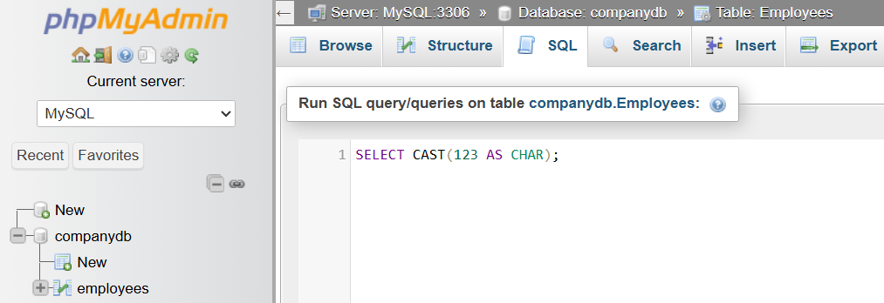
SELECT CAST(123 AS CHAR);
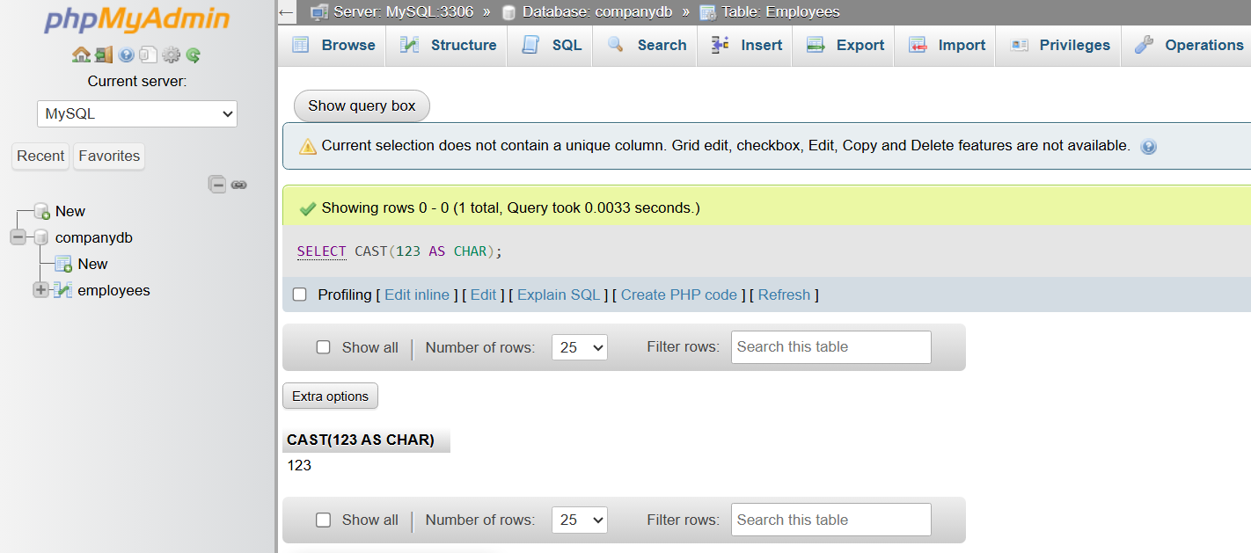

📊 Commonly Used SQL Functions
# Source: AI Source: Provided by: [Data Path: Persons Table -> ID Column: 1, Name_En Column: Motasem Essam] -> From: [ChatGPT] on [6/11/2026]
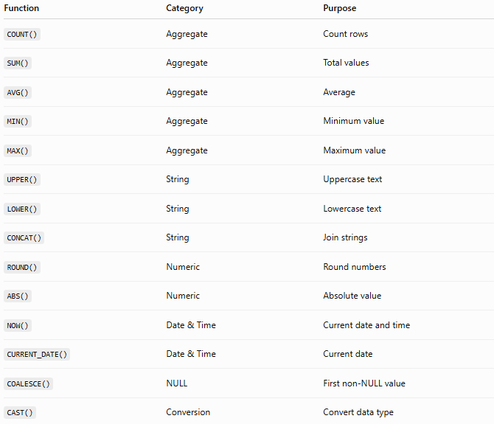
Function | Category | Purpose
COUNT() | Aggregate | Count rows
SUM() | Aggregate | Total values
AVG() | Aggregate | Average
MIN() | Aggregate | Minimum value
MAX() | Aggregate | Maximum value
UPPER() | String | Uppercase text
LOWER() | String | Lowercase text
CONCAT() | String | Join strings
ROUND() | Numeric | Round numbers
ABS() | Numeric | Absolute value
NOW() | Date & Time | Current date and time
CURRENT_DATE() | Date & Time | Current date
COALESCE() | NULL | First non-NULL value
CAST() | Conversion | Convert data type

⚠️ Important Notes
# Source: AI Source: Provided by: [Data Path: Persons Table -> ID Column: 1, Name_En Column: Motasem Essam] -> From: [ChatGPT] on [6/11/2026]
- SQL built-in functions are provided by the DBMS—you do not need to create them.
- Some functions are ANSI SQL standard (such as COUNT(), SUM(), AVG(), CAST(), COALESCE()), while others are database-specific (such as IFNULL() in MySQL or LEN() in SQL Server).
- Aggregate functions work on multiple rows, while most other built-in functions work on one value at a time.

🔢 SQL Built-in Functions Workflow
# Source: AI Source: Provided by: [Data Path: Persons Table -> ID Column: 1, Name_En Column: Motasem Essam] -> From: [ChatGPT] on [6/11/2026]
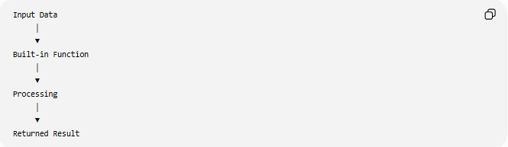
Input Data
│
▼
Built-in Function
│
▼
Processing
│
▼
Returned Result

🧠 Simple Analogy
# Source: AI Source: Provided by: [Data Path: Persons Table -> ID Column: 1, Name_En Column: Motasem Essam] -> From: [ChatGPT] on [6/11/2026]
Think of SQL built-in functions like the built-in apps on a smartphone.
- The Calculator app performs calculations → Numeric Functions.
- The Clock app provides the current date and time → Date & Time Functions.
- The Contacts app formats names → String Functions.
Similarly, SQL built-in functions perform common operations without requiring you to write the logic yourself.

🧭 Summary
# Source: AI Source: Provided by: [Data Path: Persons Table -> ID Column: 1, Name_En Column: Motasem Essam] -> From: [ChatGPT] on [6/11/2026]
SQL Built-in Functions are predefined functions supplied by the DBMS to simplify common database operations. They can manipulate text, perform mathematical calculations, summarize data, work with dates and times, handle NULL values, and convert data types. Using built-in functions makes SQL queries shorter, more readable, and more efficient.

